National University of Computer & Emerging Sciences
Homework # 2(b)
Probability
- It is common in many industrial areas to use a filling machine to fill boxes full of product. This occurs in the food industry as well as other areas in which the product is used in the home, for example, detergent. These machines are not perfect, and indeed they may A, fill to specification, B, underfill, and C, overfill. Generally, the practice of underfilling is that which one hopes to avoid. Let P(B) = 0.001 while P (A) = 0.990.
Give P(C).
$P\left(C\right)=1-\left(0.001+0.990\right)=0.009$
What is the probability that the machine does not underfill?
$P\left(B^{c}\right)=1-P\left(B\right)=1-0.001=0.999$
What is the probability that the machine either overfills or underfills?
$P\left(B∪C\right)=P\left(B\right)+P\left(C\right)=0.01$
- In a recent survey, the following data were obtained in response to the question, “If the number of summer classes were increased, would you be more likely to enroll in one or more of them?”
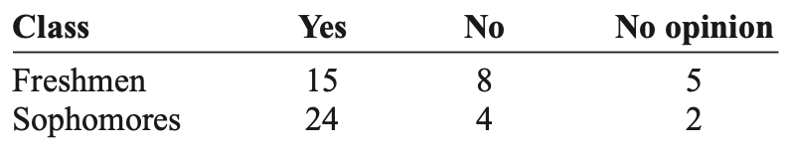
If a student is selected at random, find the probability that the student:
Has no opinion
$P\left(no opinion\right)=\frac{7}{58}=0.12$
Is a freshman or is against the issue
$P\left(freshman∪against\right)=\frac{15+8+5+4}{58}=0.552$
Is a sophomore and favors the issue
$P\left(sophomore∩in favour\right)=\frac{24}{58}=0.414$
- Poker dice is played by simultaneously rolling 5 dice. Show that
P{no two alike} = .0926;
$P\left\{no two alike\right\}=\frac{6.5.4.3.2}{6^{5}}=0.0926$
P{one pair} = .4630;
$P\left\{one pair\right\}=\frac{1}{6^{5}}.\left(6 1 \right).\left(5 3 \right).\frac{5!}{2!}=0.4639$
P{two pair} = .2315;
$P\left\{two pair\right\}=\frac{1}{6^{5}}.\left(6 2 \right).\left(4 1 \right).\frac{5!}{2!2!}=0.2315$
P{three alike} = .1543;
$P\left\{three alike\right\}=\frac{1}{6^{5}}.\left(6 1 \right).\left(5 2 \right).\frac{5!}{3!}=0.1543$
P{full house} = .0386;
$P\left\{two alike and three alike\right\}=\frac{1}{6^{5}}.\left(6 1 \right).\left(5 1 \right).\frac{5!}{2!3!}=$
P{four alike} = .0193;
$P\left\{four alike\right\}=\frac{1}{6^{5}}.\left(6 1 \right).\left(5 1 \right).\frac{5!}{4!}=0.0193$
P{five alike} = .0008.
$P\left\{two alike and three alike\right\}=\frac{1}{6^{5}}.\left(6 1 \right).\frac{5!}{5!}=0.0008$

